**Solution Architecture:**

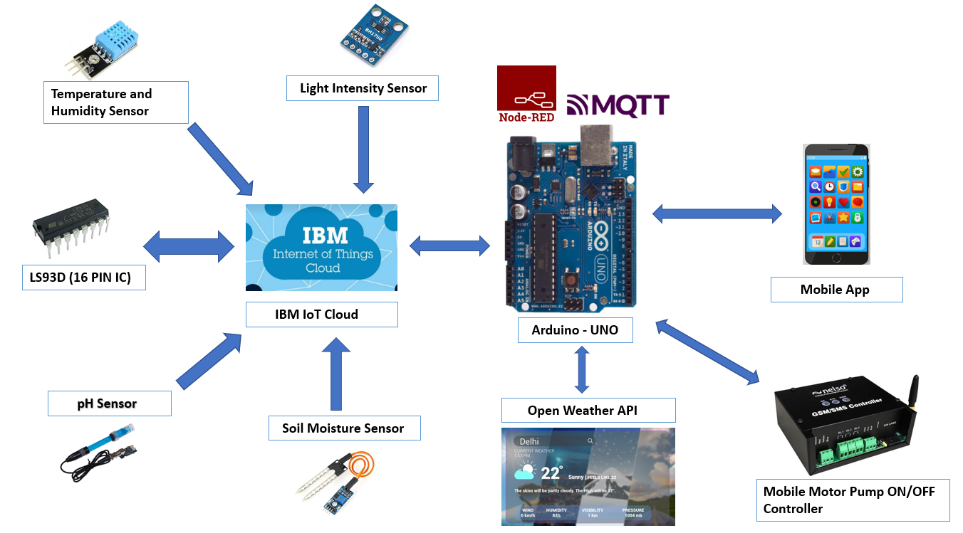

|  |
| --- |
| Key points:  •  The different soil parameters (temperature, humidity, light intensity, pH level) are sensed using different sensors and the obtained value is stored in IBM cloud.  •  Arduino uno is used as a processing unit which processes the data obtained from sensors and weather data from weather API.  •  Node red is used as a programming tool to wire the hardware, software and APIs. The MQTT protocol is followed for communication.  •  All the collected data are provided to the user through a mobile application which was developed. Depending upon the sensor values, Mobile Motor Pump controller waters the crop. |